1. **Export from raw files to the MongoDB:**
   1. Remove all duplicated recordings in first step, end up with following numbers:

**Sonata 1: 5501 files**

**Sonata 2: 1810 files**

* 1. Match Player Names with Participant IDs.

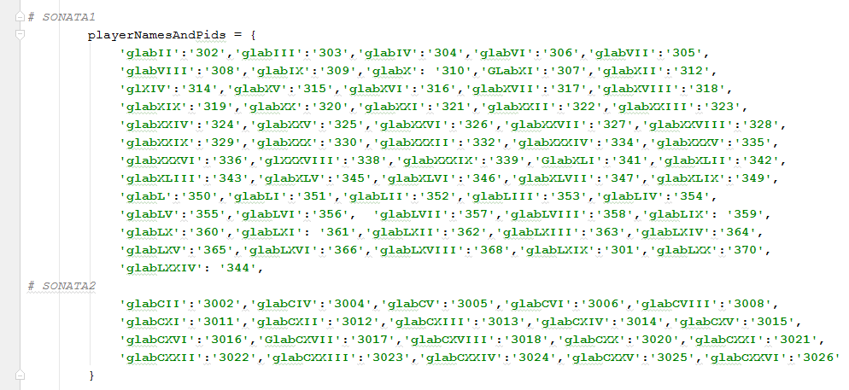

* 1. Export following variables:

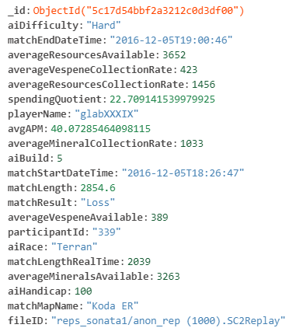

* 1. 1st pass on frequencies of „matchLengthRealTime” variable values (expressed in seconds):

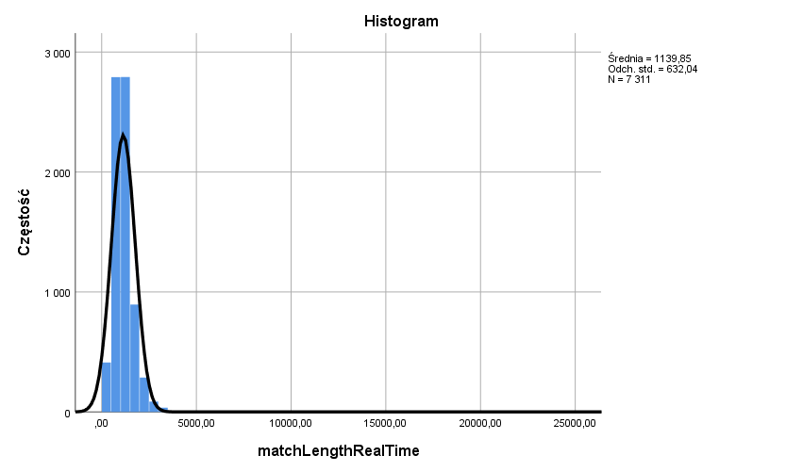

Average game length in pro SC2 is ~19 minutes:

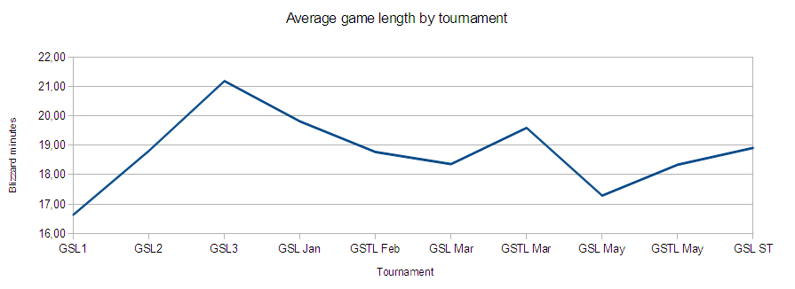

Source: https://www.teamliquid.net/forum/starcraft-2/240774-average-game-length-in-gsl

Remove two extra long games:



**23405,00** – Sonata1 pIDs:

302 (reps_sonata1/anon_rep (1242).SC2Replay),

355 (reps_sonata1/anon_rep (5126).SC2Replay)

**12156,00** – Sonata2 pID:

3011 (reps_sonata2/anon_rep_sonata2 (62).SC2Replay)

* 1. 2nd pass on frequencies of „matchLengthRealTime” variable values: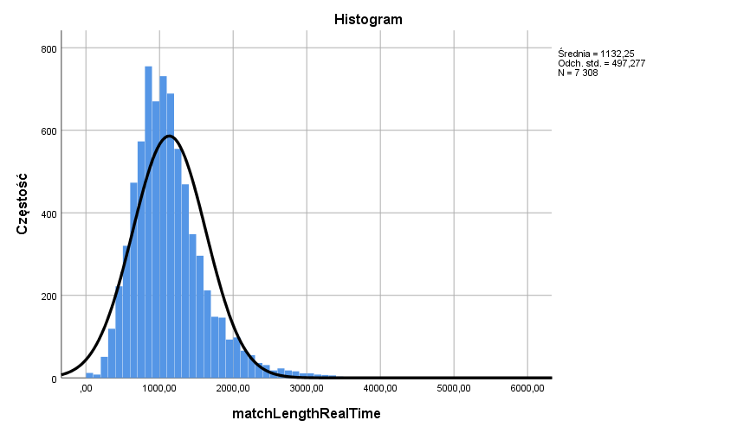

Cut right side of the distribution at point of 3 SD from mean: 2624,081 (~43 minutes). That makes for 102 recordings and 1,4% of the whole data set, 93 matches in Sonata1 (1,6%), 12 matches in Sonata2 (0,6%).

* 1. 3rd pass on frequencies of “matchLengthRealTime” variable values:

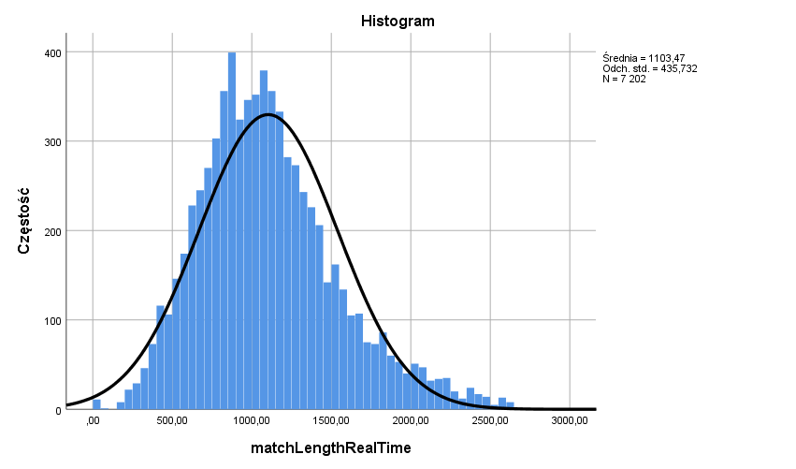

Cut left side of the distribution at point of 2 SD from mean: 232,006 (~4 minutes). That makes for 39 recordings and 0,4% of the whole data set, 16 matches in Sonata1 (0,2%), 18 matches in Sonata2 (1%).

Ended up with this replays count:

**Sonata 1: 5392 files**

**Sonata 2: 1780 files**

* 1. 4th and final pass on frequencies of “matchLengthRealTime” variable values:

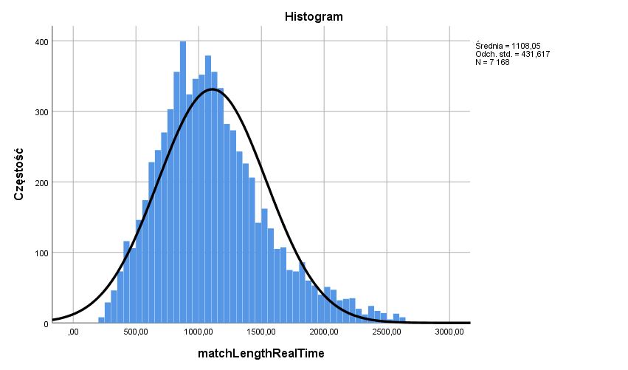

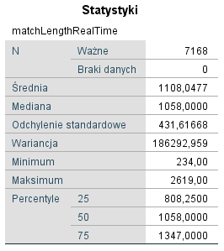

1. **Aggregate data from all replays for each participant to following variables:**

|  |  |
| --- | --- |
| **Variable name** | **Description** |
| pId | Participant IDs. |
| group | Sonata1: (1) SC2 Fixed; (2) SC2 Rand; Sonata2: (3) SC2 Rand; |
| sex |  |
| averageAMPs_qX | Average Actions Per Minute in each quarter of training. |
| ratioWins_qX | Wins ratio in each quarter of training. |
| totalMatches_qX | Number of games played in each quarter of training. |
| totalTime_qX | Total time in seconds spent in games in each quarter of training. |
| trainingMatchesLvl_Count_X | Number of games played at each difficulty level. |
| trainingMatchesLvl_SQ_X | Value of Spending Quotient indicator at each difficulty level. |
| trainingMatchesLvl_Time_X | Total time in seconds spent in games at each difficulty level. |
| trainingMatches | Total number of training games played. |
| trainingTime | Total training time in seconds. |
| winCount | Number of wins in all games played |
| lossCount | Number of loses in all games played. |
| winsRatio | Overall training wins ratio. |

SPSS Database: **sonata1_rev3_and_sonata2_rev3-combined_basic_db-181220181705.sav**

1. **Comparison of Sonata1 SC2Rand group and Sonata2 SC2Rand group:**
   1. **Average APM**

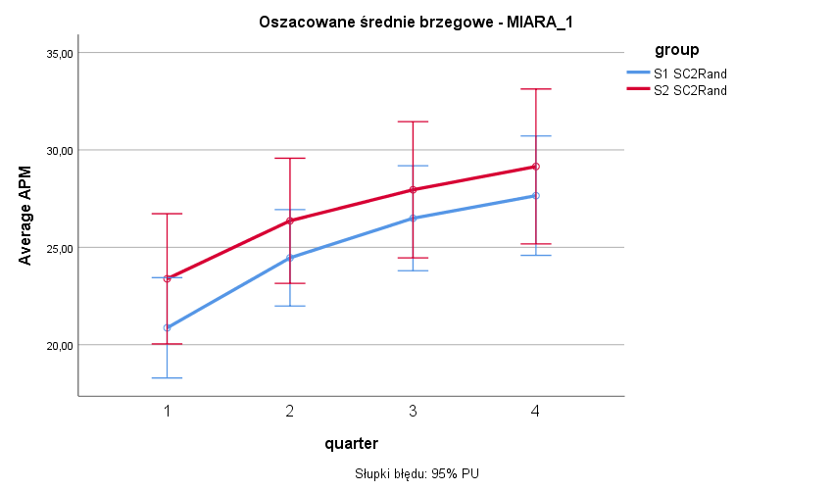

Brak efektu głównego ‘group’. Brak interakcji ‘group x quarter’.

* 1. **Wins ratio**

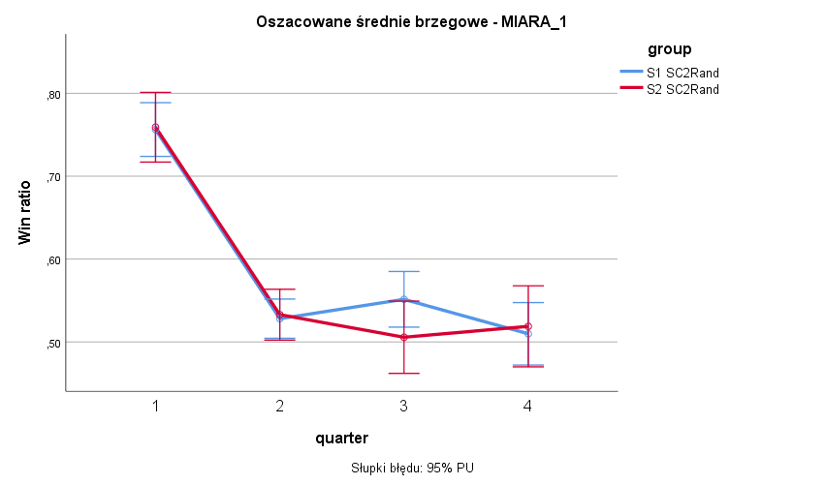

Brak efektu głównego ‘group’, brak interakcji ‘group x quarter’.

* 1. **Number of matches**

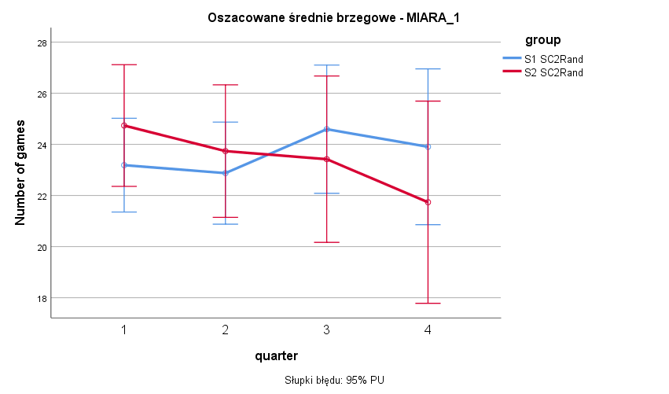

Brak efektu głównego ‘group’, brak interakcji ‘group x quarter’.

* 1. **Training time**

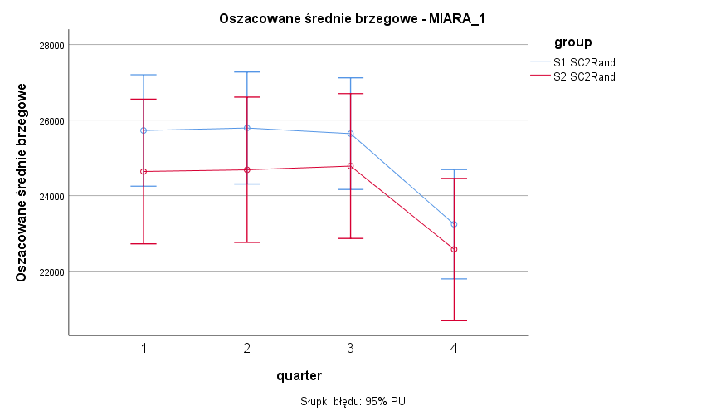

Brak efektu głównego ‘group’, brak interakcji ‘group x quarter’.

* 1. **Number of matches at levels of difficulty**

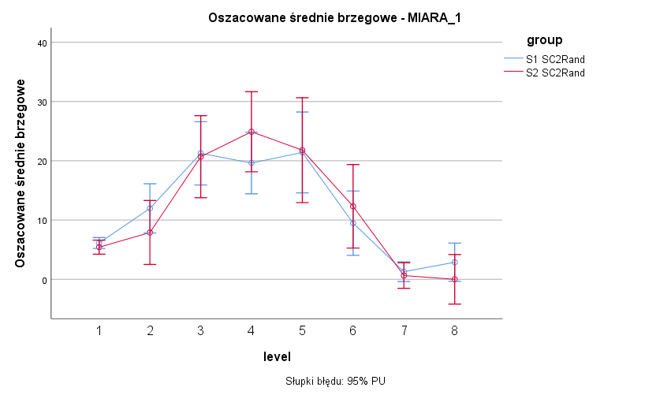

Brak efektu głównego ‘group’, brak interakcji ‘group x quarter’.

* 1. **Spending Quotient value at levels of difficulty**

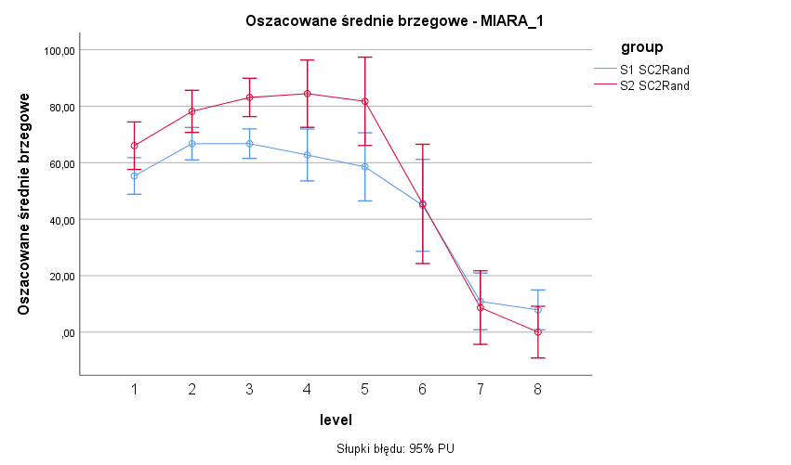

Tendencja efektu głównego ‘group’:

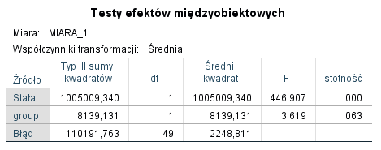

Interakcja ‘group x quarter’:

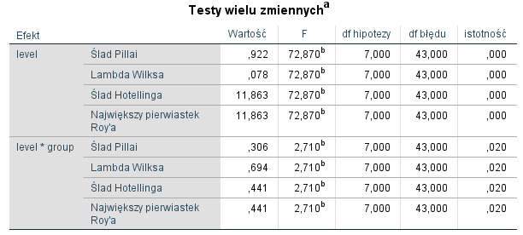

* 1. **Training time at levels of difficulty**

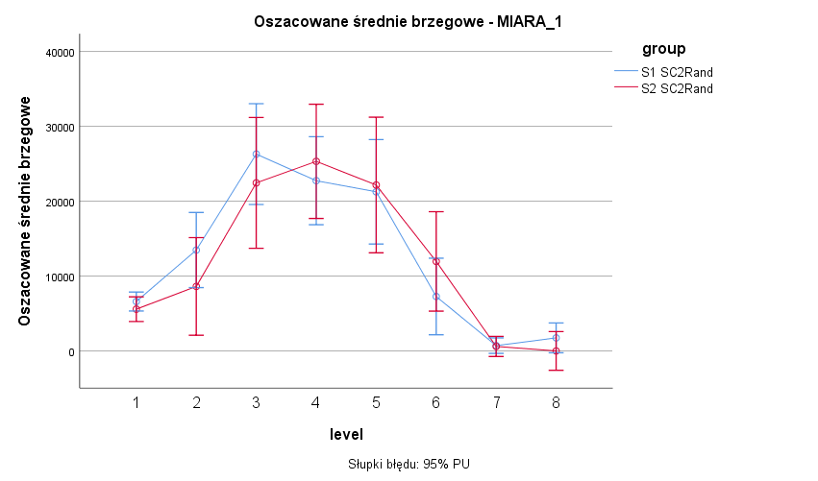

Brak efektu głównego ‘group’, brak interakcji ‘group x quarter’.